H.T No
Regulations:
A18

Sreenidhi Institute of Science and Technology
(An Autonomous Institution)
Code No: 7BC02 Date: 05-August-2024 (FN)

B.Tech I-Year II- Semester External Examination, August - 2024 (Supplementary)
ENGINEERING GRAPHICS AND DESIGN (CIVIL, CSE,IT&ECM)

Time: 3 Hours Max.Marks:70

Note: a) No additional answer sheets will be provided.
b) All sub-parts of a question must be answered at one place only, otherwise it will not be valued.
c) Missing data can be assumed suitably.

Bloom's Cognitive Levels of Learning (BCLL)

Remember | L1 | Apply | L3 | Evaluate | L5
Understand | L2 | Analyze | L4 | Create | L6

Part - A Max.Marks:20
Answer all QUESTIONS

 |  | BCLL | CO(s) | Marks
1 | Draw the convention used for representing axis. | L1 | CO1 | [2M]
2 | What is the difference between first angle projection and third angle projection? | L2 | CO2 | [2M]
3 | When the axis of a cylinder is parallel to HP and perpendicular to VP, what is the shape of its top view? | L1 | CO3 | [2M]
4 | Define an auxiliary inclined plane, auxiliary vertical plane and a profile plane. | L1 | CO4 | [2M]
5 | What is isometric scale? How to construct it? | L1 | CO5 | [2M]
6 | List basic differences between surface models and solid models | L2 | CO6 | [2M]
7 | What is Eccentricity? | L1 | CO1 | [2M]
8 | Differentiate between a triangular pyramid and a tetrahedron | L2 | CO3 | [2M]
9 | Draw the isometric view of pentagonal prism of side 25mm and height 60mm. | L2 | CO5 | [2M]
10 | Explain any two modify commands. | L2 | CO6 | [2M]
Part – B Max.Marks:50
ANSWER ANY FIVE QUESTIONS. EACH QUESTION CARRIES 10 MARKS.

 |  |  | BCLL | CO(s) | Marks
11. |  | Trace a conic section, when the distance of the focus from the directrix is 30 mm and eccentricity is equal to 3/2. Name the curve. Draw a normal and tangent to the curve at a point on it at a distance of 30 mm from the focus | L2 | CO1 | [10M]
12. |  | A 30°-60°set square of 125 mm longest side is so kept that the longest side is in the HP, making an angle of 30°with the VP and the set square itself is inclined at 45° to the HP. Draw the projections of the set square. | L2 | CO2 | [10M]
13. |  | A hexagonal prism of base 40 mm side, height 65 mm is resting on a corner of its base on the ground with longer edge containing that corner inclined at 45° to the HP and parallel to VP. Draw its projections. | L2 | CO3 | [10M]
14. |  | A pentagonal prism of base 25 mm and axis 50 mm long is resting its base with an edge at 45⁰ to V.P. it is cut by a section plane inclined at 30⁰ to H.P and bisecting the axis. Develop the lateral surface of truncated prism. | L3 | CO4 | [10M]
15. |  | Draw the isometric view of a pentagonal pyramid, with side of base 25mm and axis 60mm long. The pyramid is resting on its base on H.P, with an edge of the base (away from the observer) parallel to V.P. | L3 | CO5 | [10M]
16. | a) | Explain the role of units and limits commands in Setting up the AutoCAD drawing space. | L2 | CO6 | [5M]
 | b) | Highlight the main advantages of a CAD system in design and drafting. | L2 | CO6 | [5M]
17. |  | A circle of 30 mm diameter rolls along a straight line for one revolution clockwise. Draw the locus of a point on the circle, which is in contact with the line. Also draw a tangent and a normal to the curve, at a point 20mm from the directing line | L2 | CO1 | [10M]
18. |  | Draw the front view, top view and side view of the following Figure.  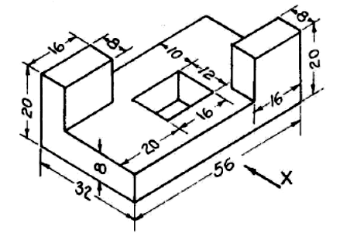 | L2 | CO4 | [10M]
-- 00 -- 00 –

